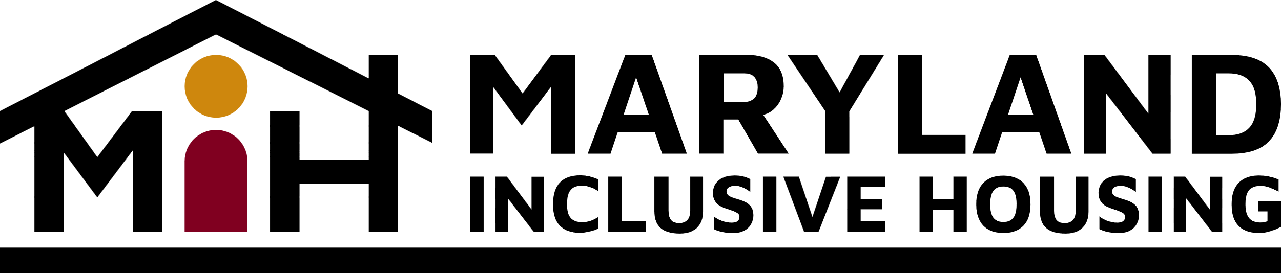

Baltimore City Housing Meeting July 10, 2023 3:30 PM – 5:00 PM via Zoom
Present: Ami Taubenfeld, Kristina Logan, Stephanie Jones, Charmeda McCready, Kane Levings, Patrick Myles, Imani Graham, Claudia Wilson Randall, Andy Krauss, Tim Wiens, Sarah Hochbaum, Sharonda Huffman, Terri Bradford
- Welcome
  - Review of minutes from June 2023
- Claudia Wilson Randall – Community Development Network of Maryland
  - Statewide network of developers and a broad array of organizations who have paid professional staff.
  - The bulk of their work is state advocacy. They have an organizer involved in Montgomery county and Baltimore City.
  - They pushed the state to do a housing needs assessment to get an idea of the numbers. It came out during the pandemic.
  - If you want to be added to the IHC mailing list email: baltimoreihc@gmail.com You can also follow the IHC on Twitter at https://twitter.com/baltimore_ihc or on Facebook at https://www.facebook.com/baltimoreihc
  - Next 12 to 18 months:
    - Growing the number of organizations that are interested in talking about the need for affordable housing. Without stable housing, new school buildings don’t help children learn.
    - Organize groups to come to Annapolis. Encourage legislature to fund preservation so that we keep the units of affordable housing.
      - It’s powerful to get people to speak about how they’re impacted by housing policies. “First person” language.
    - Maryland Chamber of Commerce is talking about housing and Economic development is talking housing, health department is talking housing. It’s about “housing and ____ “
    - Interagency collaboration could be significant for those with IDD. Help departments understand how agencies could work together to be more effective.
    - Trying to get folks thinking about things early. Identifying people who could help educate legislators about the disability community. About 1/3 of the legislators are new so this is important.
- Roundtable on Legislative Updates (Baltimore Inclusionary Zoning Laws and State and Federal Legislation)
  - The city council probably will not vote on a bill this month. The thought is it could be late August or September. There are good discussions going on regarding this.
  - Documenting stories of a person’s challenges. When dates are released, have a group participate at the city council level.
  - Sustained effort is needed! Keep asking questions about inclusionary housing to keep the issues in front of them.
- Updates on DDA Rent Subsidy, Technology, and MDOD
  - DDA is moving through the applications now that FY24 has started.
  - Tech Tuesday on July 25 will contain a focus on service providers who are new.
  - MDOD because they’re a government agency, they aren’t able to do advocacy around issues like we are.
- MIH Training Page – Andy Krauss
  - MIH has revamped it’s website. We have added trainings to our calendar.
  - Follow us on Twitter, Facebook, Linked In and Instagram.
- Updates State Collaborations – Tim Wiens
  - The Legislative Black Caucus is having a meeting Thursday at Coppin. Details to follow.
  - Tim met with Secy Beatty to see how they could work on our proposal. They asked for two tweaks.
    - They want to work on these issues on a cross disability perspective.
    - The Maryland partnership for affordable housing includes the MDOH, MDOD and DHCD who are the senior partners that collaborate with Disability Rights Maryland, People on the go, CILs, etc. She thought we should become part of the smaller work group and Tim agrees.
    - MIH would make sure units got filled, work with management companies so that if there were complaints or problems, we could mediate. We could also help individuals with their service agencies. MIH would also work on social inclusion to make sure that people were really included in those communities.
    - MIH is playing the long game to engage the new leaders in the first year to work towards the bigger solution.
- Other Items/Questions
  - July 25th from 1:30-3:30 pm the US Access Board will have a town hall meeting at the National Federation of the Blind. You can attend in person or via a Zoom live stream link.
  - Disability Rights Maryland is looking for declarations from people that use wheelchairs, walkers, etc in Baltimore city for one of their cases. Reach out to kanel@disabilityrightsmd.org
  - We’ve been talking about developers, are we also considering apartment complexes and management companies for housing? Yes we are looking at existing housing options as well.
  - Can rent subsidies be used to purchase condos? No. They are for rentals only.
  - We plan to start working on our advocacy priorities for FY25. Last year we asked for 100 units for FY24. How many additional units should we ask for? If we’re starting with 30-50 this year, maybe we should ask for 75-100 for FY24. The idea is to keep it growing. Could we get allocation by jurisdiction instead of all of them being one area or far out?

- Next Meeting
  - September 18, 2003 at 3:30 pm at The Arc Baltimore or Virtual

