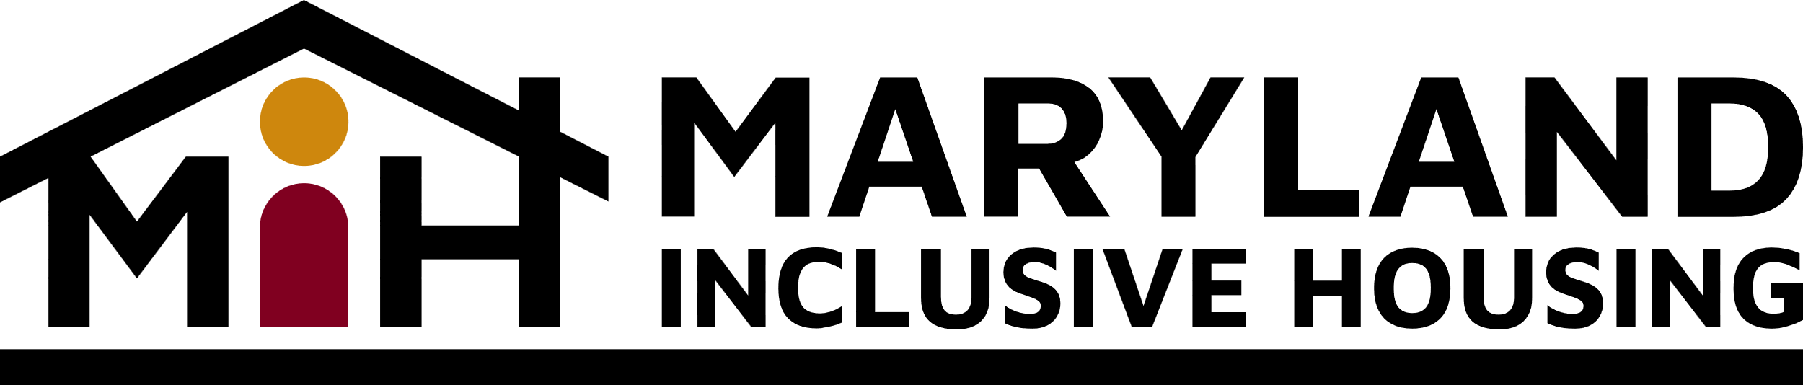
Baltimore’s Housing Meeting Minutes
November 20, 2023
3:30 PM – 5:00 PM
Present: Kristin Hauth (Service Coordination), Chelsea Hayman (MDOD), Diane Dressler, Matt Hill (IHC/PJC), Phylicia Porter (Baltimore City Councilmember), Tim Wiens, Andy Krauss, Terri Bradford
- Welcome/Introductions
  - Review of minutes from September 2023
- MD Department of Disabilities Updates – Chelsea Hayman, MDOD
  - MDOD continues to work on the 811 Grant that is due in February. The plan is to request $8,000,000, which is the total amount. Waiting on budgets to get an idea of how many people these funds can support. Will bring numbers when she has them.
  - Working on racial equity draft statement to summarize how it will be addressed in program design and development.
  - The Association on Community Living has published a technical assistance opportunity. It’s for creating health and housing systems integration. Chelsea is working on the draft. She appreciates those who have offered to support and partner on this.
  - The state’s ADU task force is looking for focus group members. Please email Chelsea if you’re interested in participating. It will occur during the first two weeks of January in person in Baltimore city. They are looking for people who are ADU owners, ADU residents, aging advocates and accessibility advocates.
    - They are looking for feedback on how to make an ADU more accessible or features that are within an ADU that are completely inaccessible.
  - Tiny homes would be considered an ADU.
- Inclusionary Housing Updates – Matt Hill, PJC
  - Inclusionary Housing Rally and Vote
    - Monday, November 20, 2023
      - @ 4:00 pm Rally at City Hall
        - Char is attending.
      - @ 5:00 pm Vote at City Hall
        - Char is attending.
        - 22-0195 IH Bill
        - 23-0369 IH Tax Credit
        - The bill appears to be in good shape. There will be an amendment with a tax on the tax credit but no cap on the inclusionary housing law. We don’t know if there will be enough votes to pass yet.
- MIH Collaboration with Kairos Development – Tim Wiens, MIH
  - She reached out to MIH to collaborate on projects that she is doing in Baltimore City. MIH has signed letters of intent for Cherry Hill and the Winston school project.
  - They would set aside 10% of the units for clients of MIH. We would provide housing support services for these people or arrange for it to happen. If we can’t get them filled, they would rent them to somebody else.
  - People with housing choice vouchers could pay for their housing using vouchers and MIH would help them navigate the funding.
  - MIH is excited about this as an opportunity to try it out. Both MIH and Kairos have the ability to withdraw from the arrangement without cause by giving appropriate notice.
- Baltimore City Disability Housing Agenda
  - Councilmember Phylicia Porter
    - She asked MIH what kinds of items the committee and other jurisdictions were working on so that they could replicate it for the city.
      - Tim described how people with intellectual and developmental disabilities need to be included in the affordable housing work in the city.
      - Inclusionary zoning laws are usually for new construction for single family homes and multi-family projects.
        - A certain percentage of what their building needs to be for a moderate income.
        - Perhaps Baltimore city could include some of the renovated units in the program with a developer who is doing a large number of units.
      - Tim described the partnership with Kairos for Ms. Porter.
      - Diane described the Bridge subsidy program. It provides state funding for a rent subsidy and then the person transitions to a housing choice voucher.
      - Chelsea shared how two counties work on this:
        - the Community Choice Homes program works in Montgomery County.
          - 40-unit program funded through recordation taxes in conjunction with the Montgomery County public housing authority in the county. These funds increase year over year.
          - Emphasis on transit-oriented neighborhoods.
          - Chelsea will send the amounts
        - Howard county administers the disability income housing unit program through the department of housing and community development.
          - It is similar to the moderately priced dwelling unit or low-income housing unit for a person with a disability level of income (20% AMI or lower).
          - It helps developers in that they do not need to produce as many units.
          - It’s a form of alternative compliance that a market rate developer has to follow.
          - Ms. Porter was wondering if this could be for homes that are renovated rather than new construction.
            - Chelsea noted that it is a challenge to make existing homes accessible.
- Updates on DDA Rent Subsidy and Technology – Tim Wiens, MIH
  - Comments on the rent subsidy were due today.
  - They have reached out to 20 people on the list to gauge their interest. 7 people are being actively processed and the rest are getting their paperwork together.
  - They have funding for 20-50 people.
- Next Meeting
  - A poll will be sent out to change the committee meeting date from Mondays. Stay tuned!

