Montgomery County Housing Committee
Meeting Minutes
Wednesday, January 10, 2024, 3:00 – 4:30 pm via Zoom
Present: Rita Harris, John Bogasky, Shannon Minnick, Char McCready, Lauren Silverstone, Tim Wiens, Terri Bradford, Andy Krauss, Diane Dressler, Tierra Medley, Zachary Marks, Chelsea Hayman, Steve Keener, Stephanie Jones, Larry Bram, Andy Krauss, Lisa Lorraine, Tigest Alemu, Sharon Cichy, Jillian Copeland
- Welcome and Introduction
  - Char welcomed the committee members.

- Review of minutes from meeting November 8, 2023
  - There were no corrections or questions.

- Presentation 1: Affordable Housing Update with Montgomery County Housing Opportunities Commission with Zachary Marks, Senior Vice President, Real Estate
  - HOC is incredibly active. We have increased acquisition of unrestricted housing (>600 units in Bethesda CBD) that's affordable.
  - Created the housing production fund with the council.
    - It’s a $100 million-dollar revolving fund in conjunction with the Montgomery County Council. It’s designed to provide a source of capital beyond just a mortgage. Money paid back to the fund gets loaned out into the next project.
    - 20% of the units are at 50% AMI and an additional 10% are MPDUs.
  - The nonprofit acquisition fund is “first loss money” designed to be some of equity used to buy the property. It looks like it will open with about $20 million in available funding. The interest rate is 1%. This makes it more attractive to private capital partners who are interested in investing. HOC can use up to 25% of this fund. It is designed to have a very fast turnaround.

  - Recently opened the Laureate (next to Shady Grove metro).
  - Pipeline projects:
    - Metropolitan in downtown Bethesda and Metro Point in the CBD right on top of the metro.
    - A 184-unit property in Clarksburg. 36 units in that community will be set aside for individuals with IDD and other disabilities.
      - It’s a single building, new construction. It will be net zero energy.
    - Small unit in Sandy spring Meadow to create ground floor accessible units.
    - Breaking ground on 413 unit across from the Laureate.
    - Hillandale will be Maryland’s first passive house. It will consume 40-60% less energy than code build properties. It will actually be Maryland’s first zero net energy home.
      - It’s two eleven story buildings. There’s a 155-unit senior (62+) affordable building. Units go from 30%-60% AMI. It’s a 4% tax credit transaction. It will have common space. The parking lot will have a solar array. The second building will be a 308-unit mixed income building from 40% AMI to market rate. There will be an indoor pool and community amenities like Starbucks.
  - Rita and Chelsea would like to talk with Zach about collaboration. Char wants to connect to set up a tour of a finished property during a future committee meeting.

- Presentation 2: Serving underserved populations in Maryland: data, barriers, and solutions with Lisa Lorraine, Jubilee Association of Maryland
  - Breaking Barriers was funded through private foundation funding in 2/2021. Demographic data showed disparities in accessing services for people of Hispanic and Asian descent – they were not accessing services at the same rates that they live in our communities.
  - BB provided outreach work and built a coalition of disability organizations that are providing services in Spanish.
  - DDA publishes the report showing race and ethnicity data county by county for enrollment in waivers, waiting list, TYs, self-directed vs traditional services, LISS and language data.
  - BB will soon publish a report with additional information.
  - Data shared with the committee:
    - 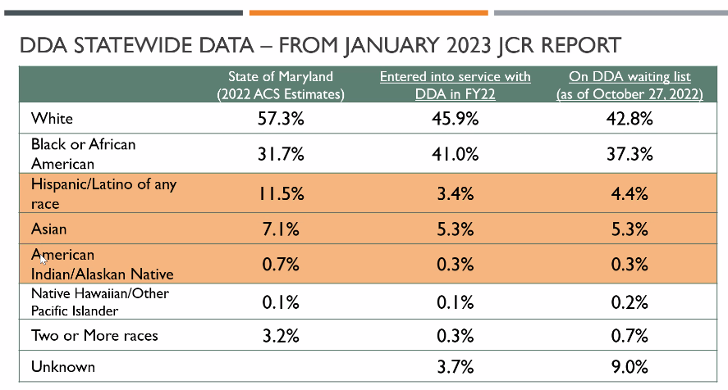
    - 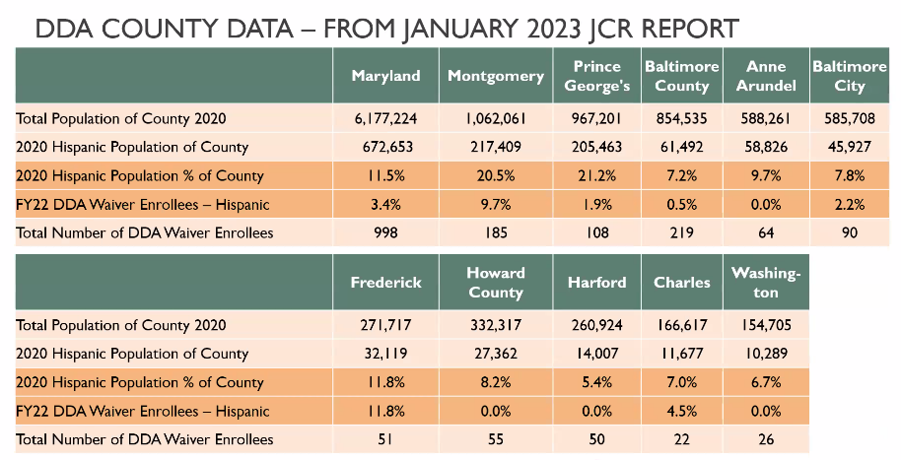
    - 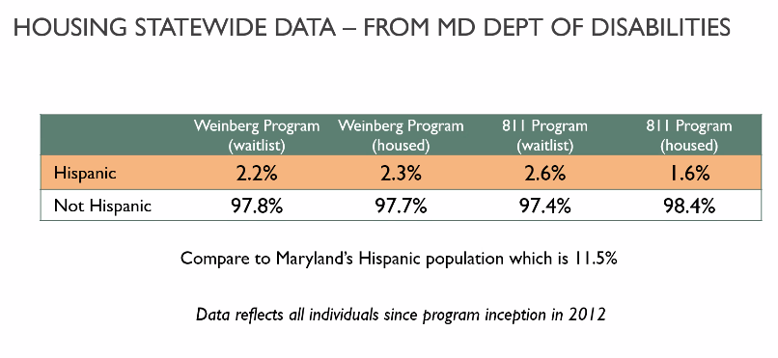
    - 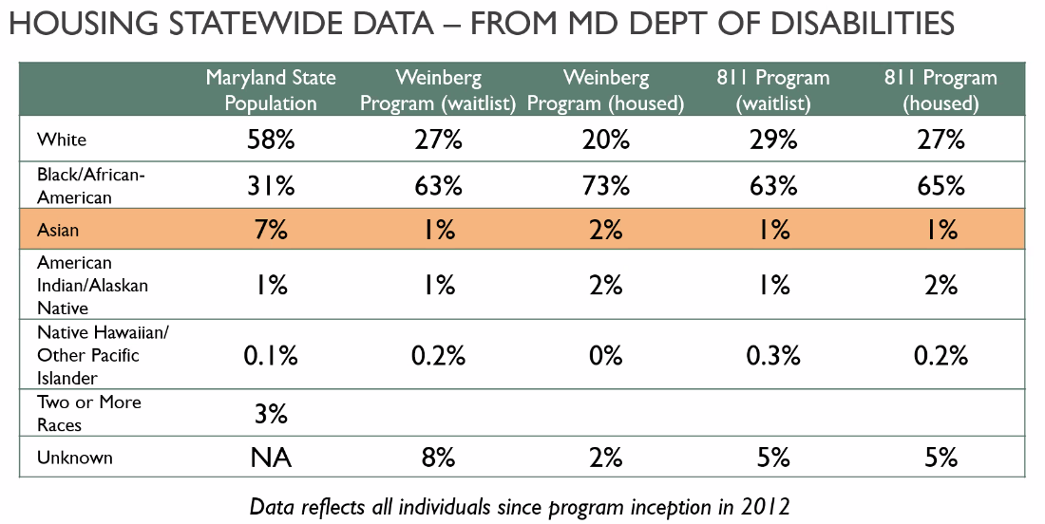
    - Identified barriers
      - Knowledge about programs, language, technology, self-advocacy skills, discrimination, cultural differences (communication, closed door response, family life preferences).
      - Housing specific barriers
        - Family living preferences – multi-generation households, immigration status issues of family members, child with disabilities not eligible to apply for housing benefits.
    - How to overcome the barriers:
      - Outreach in multiple languages, relationships with community-based organizations, training social service providers, staying present in the minds of those who make referrals to you
      - Education/Training, Support
        - Information sessions and materials in Spanish & other languages, building community relationships, Open door for questions using preferred communication channels

- Maryland Department of Disabilities Updates & Legislative Priorities with Chelsea Hayman, Director of Housing Policy, and Programs
  - Link to legislative session
  - Some pre-filed bills have been dropped. There is a lot of legislation coming out regarding:
    - land use and zoning policies. Look at preemption for manufactured homes including more construction of manufactured homes.
    - Renters and Tenants rights focused legislation. They are trying to raise the filing fee for landlords who file against a tenant for eviction as a way of revenue funding for the state housing voucher program.
    - Prioritization of families for the new State funded Housing Choice voucher program. FYI Persons with disabilities are still prioritized for the program.
    - Look out for opportunities where disability is NOT included in legislation.
    - Bills to look out for:
      - HB7/SB203 Housing innovation pilot program and housing innovation fund. Intended to help with seeding local governments to do more work to purchase and redevelop naturally occurring affordable housing. The state will serve by helping support the transaction particularly if it involves low-income housing tax credits.
      - SB269 – property tax credit for permanent supportive housing. It will allow developers who are producing affordable housing who serve the homeless to receive additional property tax credits for producing that housing (no mention of people with disabilities in this bill). There is more incentive for building less integrated housing.

  - There is a bill tracker in the department through an organization called Advocate.
  - The 811 Grant had a change in staffing in MD DHCD (Department of Housing and Community Development). They are working on getting it across the finish line. The hope is to finish it in the next week and a half.
  - RACS and ARACS Training link
  - The committee asked Chelsea to let them know where they come down on the bills and how the committee can help advocate.

- Assistive Technology (AT) Navigator, Andy Krauss, Director of Communications, Maryland Inclusive Housing
  - The Assistive Technology Navigator can be found on the MIH website.
  - Andy shared the navigator's history and took the meeting participants on a virtual tour of it.

- Open Forum
  - 1/29/24 is the community bonds grants virtual workshop at 1:00 pm.
  - In talking with a developer, a committee member found out that a child development center regulation says it must be 3000 square feet (about the area of a tennis court) which is 3 classrooms. It is not enough to make it sustainable. He was looking for ideas of why this regulation exists.

- Next Meeting
  - March 13, 2024 from 3:00-4:30 pm.

