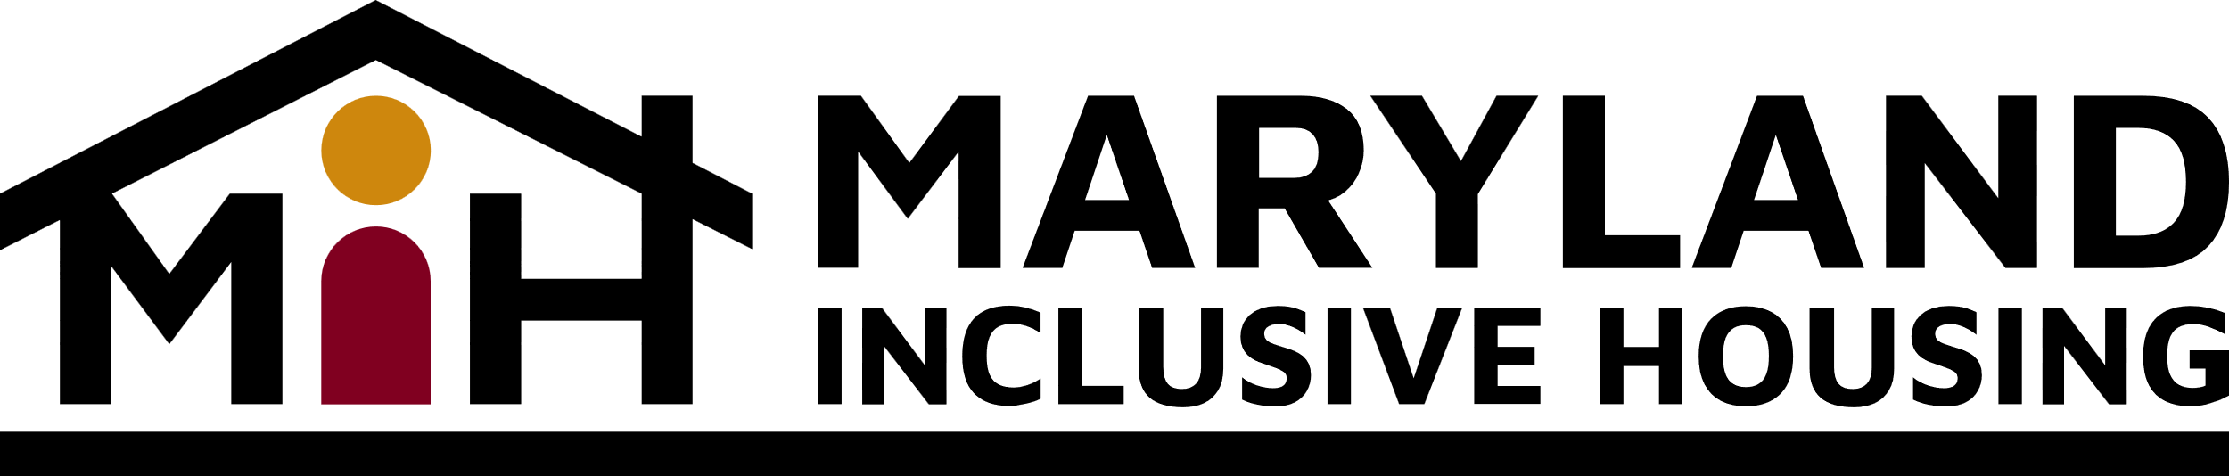

**Baltimore City’s Housing Meeting Minutes**

**Monday, June 10, 2024**

**3:00 PM – 4:30 PM**

**Via Zoom**

**Present:** Ami Taubenfeld,Diane Dressler, Kristin Hauth, Tim Wiens, Terri Bradford, Sarah Hochbaum, Andy Krauss, Vonnette Harris, Jenny Torres, Claudia Wilson Randall

1. Welcome/Introductions
   1. Tim welcomed everyone to the meeting.
2. Updates on Affordable Housing Projects planned for Cherry Hill and Winston Ave.
   1. Vonnette Harris, President/ CEO Kairos Development LLC.
      1. The Cherry Hill project has started design work. Architect and engineer have looked at the site. The site has some challenges.
         1. They would like to submit a 9% application.
         2. An application for additional funding is being worked on now.
         3. They may have to apply for one zoning variance due to the topography of the site.
         4. They would like a letter of support from us regarding the level of support that will be provided along with the ability to obtain a portable voucher for our clientele.
      2. The Winston project has not progressed as quickly as expected.
         1. Community meetings have occurred.
         2. Working with Morgan State University to build a robust community engagement strategy.
3. Inclusionary Housing Law updates
   1. Inclusionary Housing Coalition
      1. Derrick McCorvey/ Valerie Crosby/ Andy Krauss
         1. Media relations plan to make a push at the appropriate time (Op-Eds, letters to the editor, social media, etc.)
4. Report on Baltimore Mayoral/Council Elections and the Implications for Affordable Housing.
   1. Claudia Wilson Randall, Executive Director and Jenny Torres of CDN.
      1. Jenny Torres is now on board as the Baltimore City organizer. Her job will include overseeing the inclusionary housing coalition. Her email is [jenny@communitydevelopmentmd.org](mailto:jenny@communitydevelopmentmd.org)
      2. They met with Char McCready and Nick Mosby to discuss the next steps.
         1. Trying to get a meeting with Commissioner Kennedy.
         2. They made suggestions for the makeup of the board members of the Inclusionary housing coalition. They haven’t heard anything yet.
         3. They have asked for an information hearing to push forward the process so that the committee can be formed sooner rather than later.
         4. Claudia suggested someone from MIH attend the Montgomery County housing alliance meeting.
5. Updates on DDA Rent Subsidy Program
   1. Tim Wiens
      1. They are still working to address some of the bumps.
      2. Reasonable accommodations is one of the issues that they’re making progress on.
      3. If an individual is qualified and their name is taken off the waiting list, they must get approval from DHCD and a have an inspection. If this takes too long, then the opportunity is gone.
      4. There seems to be an information void in some areas about the program.

1. Autism Housing Network, state-wide assessment for Maryland? Ami Taubenfeld
   1. There is a lack of data regarding disabilities in Maryland.
      1. The state needs a census of disabilities, the number of people being served, how many are not being supported, etc.
      2. The state does not have a housing market analysis or assessment of needs for affordable housing.
      3. There was a study done during the pandemic by the National Center for Smart Growth and Enterprise. Claudia believes they are updating that.
         1. Danielle Meister is now at the State Department of Housing and Community Devlopment. Suggestion was made to ask her about data around people with disabilities.
2. Baltimore City Housing Committee Member Updates
3. Upcoming Events/Trainings
   1. The Maryland partnership for affordable housing is offering Tenant Training 101 workshop series on 6/18 from 9-4 at the Glen Burnie Heritage Crest community room in the senior building.
   2. The Maryland partnership for affordable housing is offering Evictions process training via webinar is on 6/20 at 10:00 am.
4. Next Meeting –
   1. August 19th  from 3:00-4:30 pm.