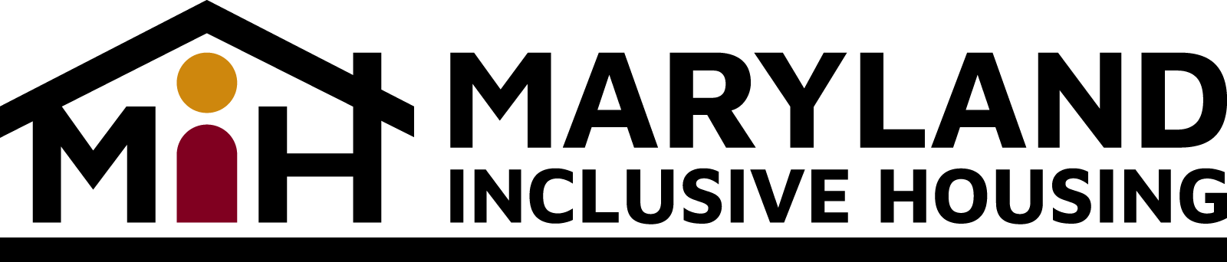
Testimony Concerning the Buget of the Maryland Department of Health
Developmental Disabilities Administration (DDA)
Submitted to the Health and Human Services Subcommittee
of the Senate Budget and Taxation Committee
and the Health and Social Services Subcommittee of the House Appropriations Committee
The Maryland Inclusive Housing Corporation (MIH) was established to help people with intellectual and other developmental disabilities (IDD) successfully access and maintain inclusive, affordable and accessible housing of their choice. To this end, MIH has set up Housing Committees around the state, including Baltimore City; the Eastern Shore; Howard County; Montgomery County; and Prince George’s County to address these issues.
Personally, I am a mother of an adult son, AJ who has an intellectual and developmental disability. He presently lives in a group home and, like any other Marylander, has a right to have a place to call home. My son regressed, during the pandemic, after graduating from high school in 2021. After my son’s three-week hospitalization in Pittsburgh, our family worked with our team and transitioned him to a group home last year. AJ now lives in an apartment with one roommate. I would love for him to have his own apartment with support. He loves living outside of our home because he is an adult and wants independence.
MIH supports funding of the DDA Rent Subsidy to continue rent payments for people who leased homes in FY23, with additional funding for an additional 100 participants in FY24, estimated average cost of $1,600 per person monthly or $1.9 million. MIH also supports initiatives for the state to partner with charitable organizations to increase funding for affordable housing in Maryland. MIH has provided a proposal to the Wes Moore Administration.
The Fair Housing Act requires recipients of federal financial assistance to do more than simply not discriminate; but take meaningful actions to overcome patterns of segregation and foster inclusive communities. On Feb. 9, 2023, HUD published a proposed rule that would faithfully implement the Fair Housing Act’s statutory mandate to affirmatively further fair housing, which is meant to overcome discrimination; provide housing choice; foster inclusive communities; and overcome patterns of segregation.

Overall, the proposed DDA budget should include opportunities for Marylanders like my son to age in place in the community with at least $1.9 million allocation for the DDA Rent Subsidy program.
Sincerely,

Sharonda Huffman
Director of Housing
Maryland Inclusive Housing
shuffman@mih-inc.org

