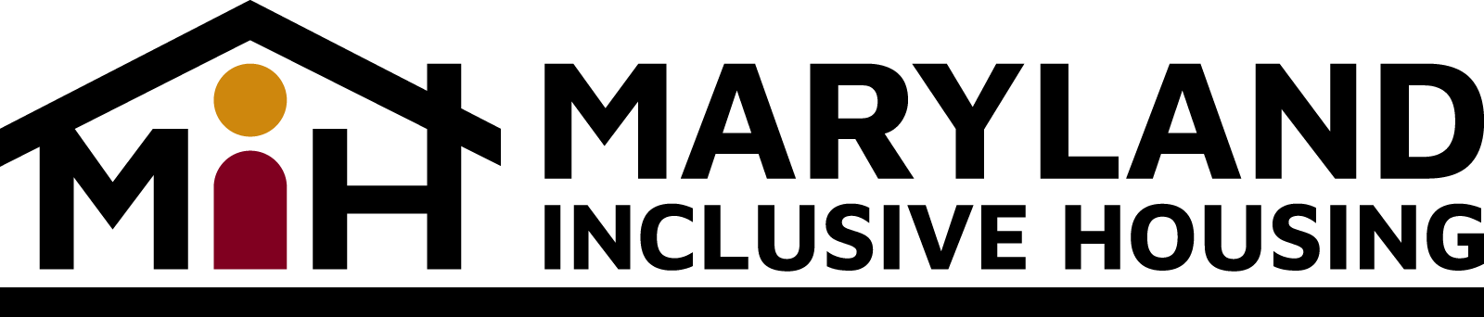
Testimony Concerning the Proposed FY24 Budget of the Maryland Department of Health
Developmental Disabilities Administration (DDA)
Submitted to the Health and Social Services Subcommittee
of the Senate Budget and Taxation Committee
and the Health and Social Services Subcommittee of the House Appropriations Committee
Maryland Inclusive Housing (MIH) was created just over three years ago to help navigate the Maryland Developmental Disabilities Administration (DDA) transformation plan to move services from a group home model toward a supported living model. Individuals with Intellectual and Developmental Disabilities (IDD), who do not live in group homes or with their families, need to identify places to live and that they can afford on their own.
MIH is funded by the DDA in order to assist these individuals by successfully attaining and maintaining inclusive, affordable and accessible housing of their choice by creating opportunities, identifying resources, connecting people and providing services. In the proposed FY24 DDA Operating Budget for FY24 is $250,000. We ask you to support this appropriation.
MIH has grown leaps and bounds since those early days of 2020 by increasing our staff from one to seven. More importantly, in 2022, we provided housing support services to more than 100 Marylanders with intellectual or other developmental disabilities. Ten of which, we successfully helped access and maintain inclusive, affordable and accessible housing. Our work is making a difference.
In addition to the DDA appropriation, MIH also receives funding from the Maryland Medicaid Money Follows the Person program.
We have engaged in doing this work in three specific ways:
- Establishing and staffing housing committees around the state to advocate for more affordable housing for people with IDD.
- Creating an information clearinghouse to help individuals, their families and service providers find, and secure affordable and accessible housing. This resource can be found on our website.
- Providing Housing Support Services (HSS) a Medicaid waiver approved services to help individuals, their families and service providers navigate the world of affordable and accessible housing.
Liam Aaron, an adult with Autism, and his family, were recently having trouble finding housing of his own, where he could create independence. MIH helped Liam and his family navigate through obstacles to secure him a terrific apartment in downtown Rockville, where for the first time, he is now working, playing and declaring residence. Success stories like Liam’s are becoming more regular, as our organization continues to grow and make a difference.
In 2022, the DDA, in partnership with the Department of Disabilities (MDOD) and the Department of Housing and Community Development (DHCD), launched a new rent subsidy program for people with intellectual and developmental disabilities. The program, known as the DDA Rent Subsidy Program (DDARSP), enables eligible Marylanders to rent a home and pay just 30% of their total household income for rent and basic utilities.
This program is vital to the work that we do at MIH. Our clients often are living on a fixed budget and do not have a full-time job. The DDARSP makes housing drastically more affordable and makes finding housing for our clients much easier. MIH supports funding for 100 additional Marylanders in FY24, at an annualized cost of $1.9 million.
We have proposed to Gov. Moore a plan that outlines our thoughts on how he and his team can increase the amount of accessible and affordable housing for Marylanders with disabilities. In this plan, MIH proposes to partner with the DDA, Maryland Department of Housing and Community Development (DHCD) and Maryland Department of Disabilities (MDOD), a charitable foundation and private developers to create affordable and accessible housing for people with IDD in Maryland.
We ask that you support this program by urging Gov. Moore’s administration to meet with MIH and partner organizations to implement this plan.
Sincerely,
Tim Wiens
Executive Director
Maryland Inclusive Housing
twiens@mih-inc.org

